**Error and Troubleshooting**

The following sections consist of basic error messages that you will find while using Surround in the python and the troubleshooting that can be done to over the error and achieve the desired output

These are the error message that we have overcome while executing the example in the Surround

To use surround we need to install the latest version of python 3.5 or above, if not you might be able use surround pipeline at full-scale

**MISSING PACKAGES**

The above message is Error message for not finding the packages, to run your code in the Surround you need install all the necessary packages hat you might be using in the program such as NumPy, MatplotLib etc.

There are very Essential library packages that needs to be install for mathematical operations and plotting of graphs so, you can over come these messages by Installing Anaconda, and then creating Virtualeny using Conda, this will ensure that all the imports works

****

**CHANGE OF VALUES**

****

The following Error message says that the vales of a certain function will be changes to a different scale in future in accordance to the changes made for the output, so these type of error messages can be ignore as it does not affect the output, but developers should be aware that these changes have been informed as they might be confused in future in program expecting a different value. Basically this is not a Error message but should be noted and can be ignored as it doesn’t affect your result.

**DIMENSIONAL ARRAY**

While predicting the vales in the following arrays developers may get the following error message as reshaping the data from dimensions.

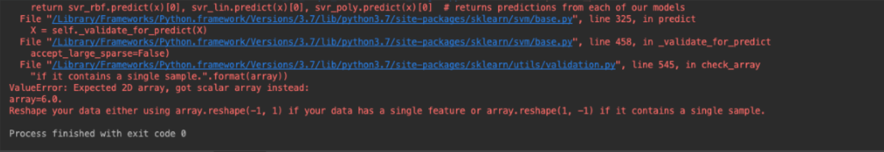

The X and Y matrix of Independent Variable and Dependent Variable respectively to DataFrame from intXX Type so that it gets converted from 1D array to 2D array.. i.e X=pd.DataFrame(X) and Y=pd.dataFrame(Y) where pd is of pandas class in python.the issues can be resolved by reshaping the vales before calling the predict ( ).

In this case, you'll need to convert it into a 1-D array and then reshape it.

**INSTALLITION**

There may be Errors for the developers while installing surround such as

Python 2.7.3 (default, April 10 2019, 05:14:39)

[GCC 4.6.3] on linux2

Type "help", "copyright", "credits" or "license" for more information.

>>> import surround

Traceback (most recent call last):

File "<stdin>", line 1, in <module>

ImportError: No module named surround

These types of errors occurs when the users are using older version or by missing packages, these types of error can be fixed by using latest version of the python and by using basic commands such as **pip3 install surround**

**DATE AND TIME ERROR:**

if isinstance(date, unicode):

try:

date = time.mktime(datetime.strptime(date, '%d/%m/%Y %H:%M:%S').timetuple())

except ValueError:

date = re.sub(r'\w+,\s\*', '', date) # removes day words from string, i.e 'Mon', 'Tue', etc.

date = time.mktime(datetime.strptime(date, '%d %b %Y %H:%M:%S').timetuple())

To solve date and time issues we have done research on many options like parsing the data or using get\_data method and then using dates.append

**Resolution:**

parse("2003-09-25")

datetime.datetime(2003, 9, 25)

We have used get\_data method in this program.

This is a wrapper for the [loader](https://docs.python.org/3/glossary.html#term-loader) [get\_data](https://docs.python.org/3/library/importlib.html" \l "importlib.abc.ResourceLoader.get_data" \o "importlib.abc.ResourceLoader.get_data) API. The package argument should be the name of a package, in standard module format (foo.bar). The resource argument should be in the form of a relative filename, using / as the path separator. The parent directory name .. is not allowed, and nor is a rooted name (starting with a /).

**FILE NOT FOUND ERROR:**

raceback (most recent call last):

File "/Users/Premtej/Documents /Projects/ (Python).py", line 9, in <module>

fileScan= open(fileName, 'r') #Opens file

FileNotFoundError: [Errno 2] No such file or directory: 'test.rtf'

This error is common in python while initialising files If file is not uploaded at right location we will face above error. This can be resolved by rechecking the location of the files uploaded or re-uploading files of the right path

**TRY CATCH EXCEPTION:**

>>> try:

assert isinstance(stage, Stage)

... except ValueError, IndexError: # To catch both exceptions, right?

... pass

...

Traceback (most recent call last):

File "<stdin>", line 3, in <module>

IndexError: list index out of range

The problem here is that the except statement does not take a list of exceptions specified in this manner. Rather, In Python 2.x, the syntax except Exception, e is used to bind the exception to the optional second parameter specified (in this case e), in order to make it available for further inspection. As a result, in the above code, the IndexError exception is not being caught by the except statement; rather, the exception instead ends up being bound to a parameter named IndexError.